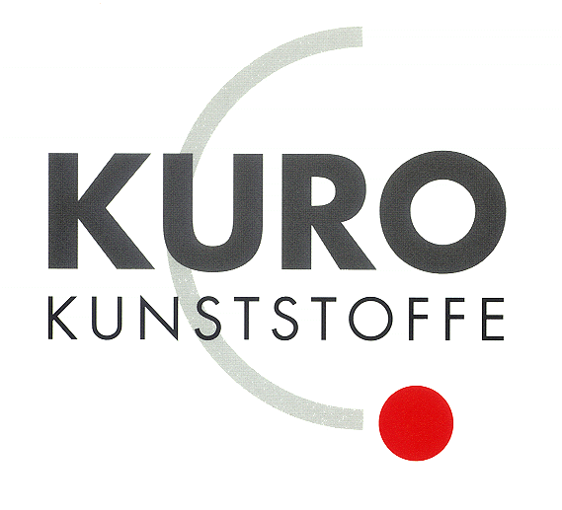

KURO – Information for invitation to tender

Product:
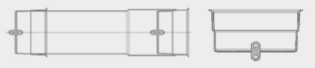

PP sealing cap with anchoring eye

Information for invitation to tender:

 | Pos:....................... | PP End caps 110 mm / Colour: black
 |  | Material: PP dimensionally stable / with an anchoring eye inside and outside
 |  | Typ „INA“ / System KURO o. glw. (www.kuro-kunststoffe.de),
 |  | supply and install, as an addition to pos: ...........
 |  | Amount:............Pieces UP: ....... TP: ........

